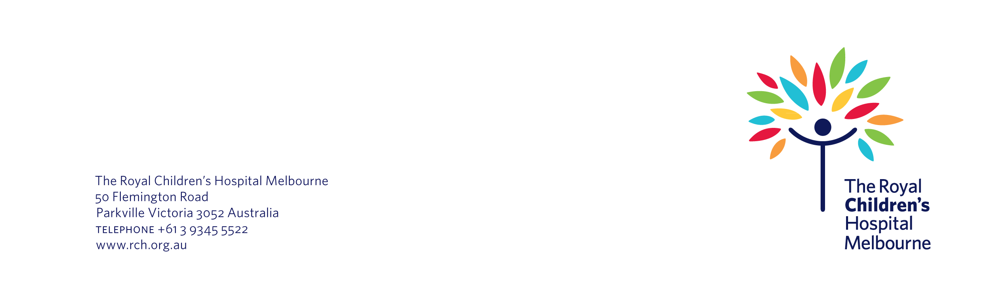
6 December 2022

Re: | We are inviting you to take part in a survey about sleep
Study number: | 89495

Dear Ms Ng,

As you know, last year your child took part in the Good Night, Sleep Tight program at The Royal Children’s Hospital (RCH). We are now inviting you to complete a survey about your experiences with the program. A student, Jessica Adams, is doing this survey as part of a research project called, Sleep and Children. She will use the results towards her PhD in physiology. We will also use the survey results to try to improve the Good Night, Sleep Tight program.

This letter gives you information about the survey.

About the survey

You can complete the survey online, via the link at the end of this letter. The survey will take about 20 minutes to do. It asks about your child’s sleep patterns before and after they took part in the Good Night, Sleep Tight program. It also asks about their health and how they are doing at school.

We have tried to make sure that the questions in the survey are sensitive and appropriate. However, if you find any of the questions problematic, you can choose not to fill them out. If you find the survey distressing, you can stop filling it out. You can also contact us to let us know how you are feeling. We may be able to link you in with free support.

We are doing this survey for research purposes. This means it will not directly help your child. However, we hope that the information will help improve the Good Night, Sleep Tight program. This may help other children with sleep issues in the future.

Storing your child’s survey information

As part of this project, we will collect and use personal and health information about your child for research purposes. We will store the electronic survey information securely on an internal server at the RCH. We will store the paper records inside a locked filing cabinet in the RCH’s Better Sleep Clinic.

We have taken steps to protect the information that you share with us in the survey. At the end of this letter, you will find a unique link to your survey. You should not share this link with anyone. The survey is encrypted so that only the right people can access it. We have also made sure that our survey software has compartmentalised – that is, divided up – the questionnaires. This means that only the researchers in this project will be able to see your survey responses when they log onto the survey software.

These people may access your child’s identifiable information:

- research team involved with this project, who will come from the RCH and Murdoch Children’s Research Institute
- RCH Human Research Ethics Committee.

Sharing information

To advance science, medicine and public health, we may share your child’s deidentified data with any current and future funders, research projects, biobanks, medical journals or data research repositories. Some of these organisations may be located overseas. Any data that we send overseas is not protected by Australian laws and regulations. By taking completing the survey you are giving us permission to do this.

If we share your child's data, we will remove identifying details such as their date of birth and give the data a special code number. Only the research team can match your child’s identity to their code number. They will only do this if necessary to do so.

We will also put security measures in place to protect your child’s data if and when we transfer it to other people. We will never email your child’s information to people. After de-identifying your child’s data, we would safely share it with other researchers by use of a Virtual Private Network (VPN). A VPN is an online privacy tool that will keep your child’s data safe from people on the internet. However, there is still a small risk that your child’s information could be wrongly accessed by other people.

Despite our best efforts, there is a small chance that your child could be re-identified by someone outside of this research project. In the unlikely event that this happens, someone from the research team will contact you. If, at any point, you think that your child may have been re-identified, please let us know.

Storage of information

This is a short-term student project that is being completed for assessment purposes only. For this reason, we will retain the project data for 12 months after the completion of the project. After 12 months, the data may be securely destroyed as required by law. At the end of the project we may securely delete our electronic records, and securely shred our paper records.

Accessing information

You have the right to access and correct the information we collect and store about your child. This is in line with relevant Australian and/or Victorian privacy and other relevant laws. Please contact us if you would like to access this information.

Final letter

At the end of the project we will send you a final letter. This letter will explain what we found out in this survey – in other words, our project results. The letter will not have any information specifically about your child.

Taking part in the project is up to you

It is up to you whether or not to take part in this project. You do not have to fill out the survey if you do not want to. If you decide not to take part in this project, your child can still get the best available care.

You can withdraw from this project if you want to. However, if you have already submitted your survey to us, we will continue to use the information you have given us. Please only take part in this project if you are happy with this approach.

Filling out the survey – next steps

If you are happy to take part in this project, you can fill out the survey via this link. This link is unique to you. Please do not share it with anyone else.

If you start to fill out the survey but then need to take a break, you can do so. You can choose to save your answers and then return to the survey later.

We will only have access to your survey results once you select ‘submit’ at the end of the survey. Once you submit your survey to us, you cannot change or withdraw your survey answers.

More information

If you would like any more information about the project, please contact me by phone on (03) 8888 7777 or by email on laralevitsy@royalchildrens.org.au.

Thank you very much for your time.

Yours sincerely,

Dr Lara Levitsky
Director
Better Sleep Clinic
The Royal Children’s Hospital

You can contact the Director of Research Operations at The Royal Children’s Hospital Melbourne if you:
- have any concerns or complaints about the project
- are worried about your rights as a research participant
- would like to speak to someone independent of the project.
The Director can be contacted by telephone on (03) 9345 5044.

